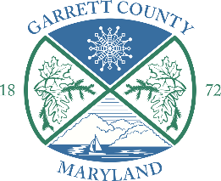 | Garrett County Government  203 South Fourth Street, Room 208, Oakland, Maryland 21550  garrettcountymd.gov/liquor-control-board –  Phone 301-334-1925 – Fax 301-334-5023  liquorcontrolboard@garrettcountymd.gov  Board of License Commissioners - Liquor Control Board | Board Members  David L. Moe  Michael J. Fratz  Lisa M. Herman

NOTICE

Notice is hereby given that the individuals named below have applied to the Garrett County Board of License Commissioners for a Class D Beer, Wine & Liquor On-Sale 7-Day License, pursuant to the provisions of the Maryland Annotated Code, Alcoholic Beverages Article.

Applicants and Business Information:
Business Entity / Trade Name: Friendsville Outpost, LLC
Applicants: David Wampler & William Wampler
Proposed Licensed Premises: 254 Maple Street, Friendsville, MD 21532
Further notice is hereby given that a public hearing on the application will be held on Thursday, August 13, 2026 at 11:15 AM. The hearing will take place in Public Meeting Room 209 of the Garrett County Courthouse, 203 South Fourth Street, Oakland, MD.

By Order of the Board of License Commissioners
Lisa Herman, Chairperson

